Chapter 4, Solution 40.

To obtain V_{Th}, we apply KVL to the loop.
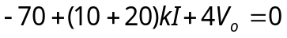
But 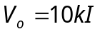
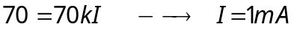
To find R_{Th}, we remove the 70-V source and apply a 1-V source at terminals a-b, as shown in the circuit below.

b
20 Ω
4 V_{o}
10 kΩ
+
_
+
–
V_{o}
I₂
a
I₁
④
①
+
–

1 V

We notice that V_{o} = -1 V.
